Nepal College of Information Technology
Unit Test
Fall 2013
Program : BE CE Time : 2 hrs
Semester : (I) FM : 70
Subject : Engineering Mathematics-I PM : 35

- Candidates are requested to give their answer as far as practicable in their own words.
- The figure in the margin indicates the full marks
- Attempt ALL question

1. a) Find the altitude of right circular cone of maximum volume that can be inscribed in a sphere of radius a. 8
b) A function is defined as follows,
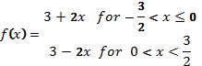
Show that f(x) is continuous at x=0 but not derivable at that point. 7
2. a) If ,show that 7
i)
ii)
b) State Rolle's Theorem theorem and verify it for
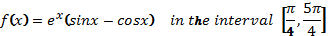 8
3. Integrate following,(any three) 15
a) 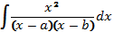
b) 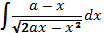
c) 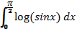
d) 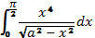
4. a) Find the Reduction formula for 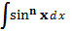 and evaluate the formula for n = 5. 7
b) State and prove L-hopital rule and evaluate 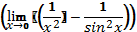 8
5. Answer following 10
i) Find the points where 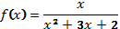 is discontinuous.
ii) 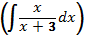
iii) 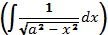
iv) 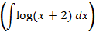
v) Find the range and domain of y = x sin x

